**Multi-Modal Fusion Imaging Techniques in Disease Diagnosis: A Comprehensive Systematic Review**

**Names of Authors:**

**Abstract:** The advancement in the medical imaging sector especially in cases involving neurogenetic disorders evaluation is quickly leading to the discarding of medieval imaging technologies. Our aim is to conduct an extensive review in a new science area that focuses on using mixed modes fusing visual imaging and prognosis diseases and more specifically Alzheimer’s disease (AD). This review paper comprehensively outlines various diagnostic approaches using the neuroimaging modalities i.e. magnetic resonance imaging (MRI), positron emission tomography (PET) and convolutional neural networks (CNNs). The overall goal is to determine whether these multi-modal fusion methods increase the diagnostic precision associated with neurodegenerative disorders and shed some more light on the pathological processes that lead to neurological damages. Moreover, its assessment covers issues related to the resolution of diagnostic difficulties with respect to neurodegenerative disorders via ensemble learning designs, joint learning architectures as well as attention oriented multiple model fusion approaches. This study’s efficacy relies on the multi-modal fusional approach where the various modalities of spatial representation is used for viewing the pathology associated with normal health, the MCI and AD. There is also an existing body of literature that explores MPI-MRI and It indicates the data heterogeneity, need for more standardized approaches, but promising results. To conclude, this is just one more piece of literature joining the ever-developing field of multi-mode fused imaging in disease diagnosis. Such methods show that over time, they can change people’s views about diagnosis and single approach for treatment of neurodegenerative disorders.

**Keywords;** convolutional neural networks, positron emission tomography, magnetic resonance imaging

**1. Introduction**

Multi-modal fusion imaging techniques have revolutionized diseases diagnoses and how persons visualize the terrain in disease diagnosis (Deng et al., 2019; Tan et al., 2020). A new approach whereby imaging information from various modalities are combined for a better understanding of complex diseases (Maqsood et al., 2020; Kang et al., 2021). Recently, there is increased demand for this methodology due its potential towards enhancing accurate diagnoses as well as comprehension of multiple diseases. MRI, PET, and CNNs are frequently used in comprehending diseases like AD (Song et al., 2021; Deng et al., 2019). Moreover, increasing incidence of neurodegenerative diseases, particularly AD is now viewed as a major public health problem that not only the patient but also the healthcare cost pays. Considering that these are extremely complicated circumstances, simple methods of diagnosis is inadequate. Neuroimaging research is being transformed and revolutionized by multi-modal fusion imaging that provides higher yielding and more insightful diagnostic tools besides enhancing understanding of pathogenesis mechanisms.

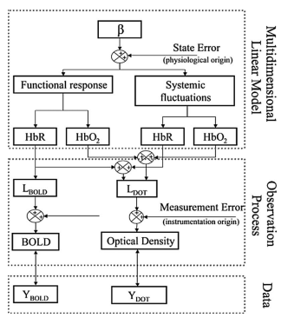

**Figure 1:** Multimodal Fusion Imaging

Due to the fact that there is no specific medication for treating AD, which is the progressive development of cognitive decline, diagnosis at an early stage becomes very important (Kang et al., 2021; Du et al., 2016). However, traditional neuroimaging, which often only use single-modal approaches such as MRI or PET, is challenged by the diverse and subtle pathological changes encountered in AD (Song et al., 2021). This has therefore led to researchers use of multi-modal fusion imaging that combines information from varied sources resulting in descriptive dementia stages. It includes a mixture of MRI imaging and 18–fluorodeoxyglucose positron emission tomography (Ortega et al., 2020; Song et al., 2021). CNN models have explored this field in other studies using its capacity to analyze complicated neuroimaging datasets. Combined, these approaches create a multimodal terrain for the imaging of multi-modal fusion imaging which not only differentiate but also characterize the space and function degeneration in neurodegenerated areas (Zhang et al., 2020; H. Wang et al., 2009; C. Zhang et al., 2019). The main objectives of this research paper are as follows:

* Examine and assess various approaches for determining diseases on neuroimages such as CT, PET, MRI and CNN.
* Evaluate the capabilities of multimodal fusion imaging as a diagnostic tool for neurodegenerative disorders. Particularly, the ensemble learning approaches, multimodal image fusion, and attention based multi-modal fusion techniques.
* Develop a generalized approach in the diagnosis of diseases through cognitively healthy controls, MCI, and diagnosed cases of AD.
* Demonstrating how multi-modal fusion imaging can change case diagnostics and providing scalable, multiple purpose perspectives in the interpretation of abnormal conditions.
* Address issues of interoperability in multi-modality fusion imaging. Investigate possibilities of more research and application into tailored therapy approaches for the future.

**2. Methods**

A systematic search strategy was employed to identify relevant literature. Inclusion criteria comprised studies focusing on multi-modal fusion techniques for disease diagnosis, specifically in the context of neurodegenerative disorders. A total of 13 articles were selected for in-depth analysis.

**3. Ensemble Learning Architectures**

Recently, ensemble learning architectures have become extremely important for the diagnosis of diseases especially AD. These architectures utilize the ensembles where multiple models share intelligence in order to achieve better predictions (Kang et al., 2021). Particularly in neuroimaging where ensemble learning comes out significantly for the appropriate diagnosis and integration of different image modalities as well as slices are necessary. In a recent study by Kang et al. (2021), one of the notable ensemble learning architectures for identifying Alzheimer's disease is based on dual models and two-dimensional convolutional neural networks). In their classification efforts for Alzheimer's Disease (AD) versus cognitively normal (CN) subjects, the best 11 coronal slices of grey matter density are determined during ensemble learning process. Next, these images were cropped into different portions and these slices were utilized for training the discriminator networks, VGG16 and ResNet50 which was combined through majority voting. Ensemble method is composed of 3 classifiers with spatial features from MSELS and error minimization based on MMIBCM, respectively. The ensemble method shows an accuracy of 90.36%, 77.19%, and 72.36%, for separating AD from CN, AD from mild cognitive impairment (MCI), and MCI from CN.

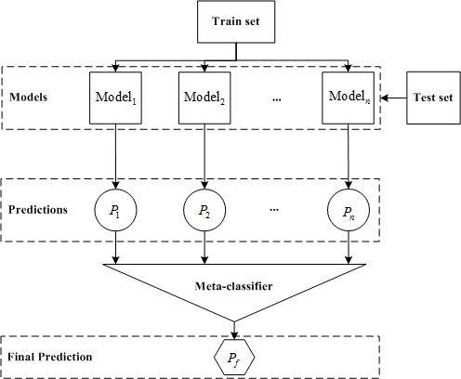

**Figure 2:** Ensemble Learning Architecture

Another outstanding contribution in the class of ensemble learning is the work by zhang and Shi, 2020 that suggests a deep multi-modality fusion networks based on the technique of attention for diagnostics of Alzheimer’s disease. It utilizes an attention based model for selective feature extraction from both MRIs as well as PET branches. Each of these data determines the autonomic ratio assign of automatically fusion. This approach uses multi-modal fusion in combination with the hierarchical fusion approach to ensure it is effective and that this approach contributes considerably to higher precision AD diagnosis. The attention model in this ensemble network is effective as it allows focusing on the areas of interests thereby fusing multi modal data and out performing the state of the art approach by providing classification results of 95.21%, 89.79% and 86.15%

In summary, it can be stated that the ensemble learning architectures are indeed one of the breakthrough discoveries in disease diagnostics, especially on the complicated terrain of neurodegenerative diseases. Multi-modal data and slices, collectively decided by several models, possess immense power that could lead to improved diagnosis and knowledge about the underlying disease. Ensemble learning as applied to neuroimaging- based disease diagnosis is illustrated by the preceding ensemble architectures.

**4. MRI and PET Fusion**

The combination of MRI and PET in neurodegenerative diseases diagnostics is very important because it supplies additional data for more precise determination. As illustrated by Song et al. (2021), this multimodal fusion approach is most critical when diagnosing diseases such as Alzheimer’s that require accurate and early detection for successful treatment. This study by Song et al. (2021), outlines the useful multimodal image fusion method by using both MRI and PET when diagnosing AD. The diagnosis of Alzheimer’s needs to be early for proper treatment since this disease destroys the brain function, thinking and memory forever. Computer-aided diagnosis has employed deep learning with multimodal images, which have shown to be effective and highly accurate. According to Song et al. (2021), FDG-PET and brain MRI can be utilized together in order to develop an approach for merging gray matter tissue segments via registering and coding using masks. GM-PET is therefore a new modality that takes into account relevant areas of pathology in ad diagnostics yet preserving both contours and the metabolic features. It employs 3D simple CNN in the first frame and uses 3D multiscale CNN for the binary task for the multiclass task. Finally, we had some final tests using ADNI data and it is clear that our fusion approach always beats any single models or feature coupling method in terms of performance. The method offers higher effectiveness than other technologies and demonstrates that it can be used for more accurate diagnosis of AD (Song et al., 2021).

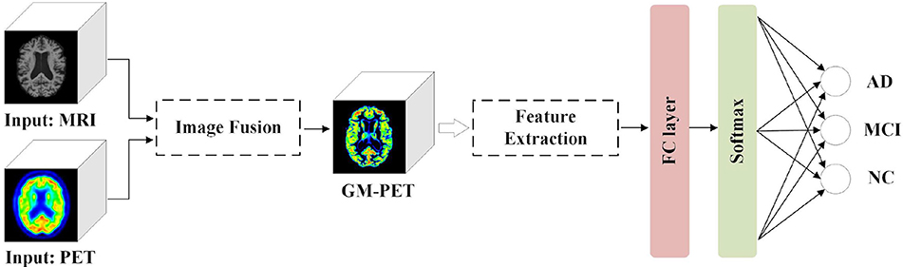

**Figure 3;** MRI and PET Fusion

Recently, Zhang et al. (2020) propose a multi-modal neuroimaging fusion approach using MRI and PET for diagnosing Alzheimer’s disease. An attention mechanism is employed in the proposed deep multi-modal fusion network so as to focus on significant characteristics while discarding irrelevant data. In addition, using an attention model whereby fusion ratios depend on importance assigned to data makes multi modal fusion efficient. Therefore a hierarchical fusion strategy offers potential for taking advantage of low level and high level features from a multiply modal data. The last classification result was 95.21%, 89.79%, and 86.15% for NC/AD, SMCI/PMCI, and Four-Class using the ADNI dataset, respectively, which confirmed its superiority in evaluation. Attention scheme facilitates the concentration on areas of interest allowing for fusion of multimodal inputs with convincing results. There are various reasons why MRI-PET fusion plays a key role in Alzheimer’s diagnosis.

PET is used with MRI to determine function based on metabolic activity as opposed to high resolution structure offered by MRI (Zhang et al., 2020). Combining these will draw on the merits of each and lead to better comprehension of the illness. These suggested fusion techniques in the above articles demonstrate the possibilities of this method not only as regards Alzheimer’s disease but also the development in multimodal imaging as a future diagnostic in the field of medicine generally. Nevertheless, the combination of MRI and PET is currently the latest medical imaging technology that can be adopted for diagnosis of diseases, particularly neurodegenerative disorders such as Alzheimer’s disease. Integration of structurals and functionals data into newly created fusion methods which make possible better early diagnosis of diseases.

**5. Attention-Based Multi-Modal Fusion**

A new technology known as multimodal attention based multi-model fusion improves on the specificity of the diagnosis by providing a highly detailed picture of the disease processes in changing environments (Zhang et al., 2020). Therefore, this new technique should be properly applied during successful exploitation of data contained in MRI and PET by selecting items and omitting unimportant facts through attention manner. The work presents a deep multimodal fusion network for the automatic attention model which provides different ratios of the fusion related to the most valuable features from MRI and PET branches. The inclusion of advanced attentional mechanisms allows the system to choose characteristics for each mode and consequently improves aggregation.

Here, it is a hierarchical model that includes both the low level and high level features, finally producing an accurate multimodality fusion (Zhang et al., 2020). Using ADNI empirically, it becomes clear that the proposed approach surpasses other algorithms and displays good classification on a variety of tasks. Zhang and Shi’s attention-based approach departs from typical fusion method because it allows the network to pay close attention to the critical features. It increases diagnostic precision and adds insight to the basic disease process. As compared to other models, the attention model’s unique ability is to narrow down on vital information across MRI as well as PET modalities, which is beneficial since it makes the diagnostic model work better. Therefore, considering the above, focus on multi-modal based on attention is one of the most accurate approaches for identifying diseases. The work of Zhang and Shi shows that attention mechanisms can increase the performance of multi-modal fusion networks (Zhang et al., 2020). With technological developments, attention-based methods for fusing medical images are likely to revolutionize the precision and comprehension in diagnosis.

**6. Multi-Model Image Fusion for Precision Medicine**

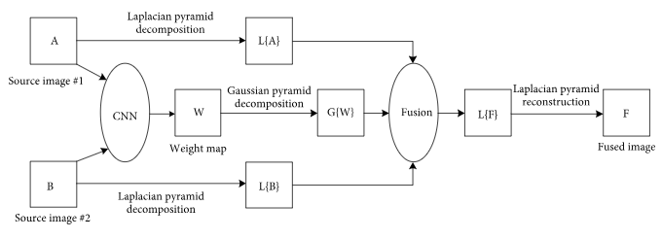

**Figure 4:** Multimodal Image Fusion

Multi-modal integrated imaging is critical in the era of precision medicine towards developmental diagnosis and therapy management of malignant tumours (S. Wang et al., 2016). This study examines the use of multi-modality image fusion technique and its importance in accurate cancer diagnosis and treatment. As noted by Wang et al. 2015, multimodal imaging fusion is important in order to provide sufficient data for correct tumor localization, qualitative diagnosis, quantitative tumour classification, designing treatment plans and, if need be, intraoperative monitoring. Multimodal imaging fusion systems provide strong technical support for precision oncology through integration of data from various imaging modalities and perspectives. It shows the usefulness of the proposed Algorithm through a Boundary Measured Pulses Coupled Neural Network Fusion Strategy and Energy Attribute Fusion Strategy in Non-Subsampled Shearlet Domain over various Medical Diagnostic Problems like Glioma, The algorithm surpasses many of currently available approaches and indicates high capabilities for refinement of medical diagnosing.

**7. Nonlinear Graph Fusion for AD Classification**

It is still an important challenge for the accurate diagnosis of AD, and its precursor MCI. This paper introduces a novel technique referred to as nonlinear graph fusion which is efficient in combining multi-modality data to enhance classification (Tong et al., 2017). For the usual ways of categorisation of AD, they have been based on linear combinations of kernels or similarity measurements in several modalities. On the other hand, Tong et al. (2017) argue that they have developed a multi modal classification framework that relies on pairwise similarity determined separately for every individual mode. A nonlinear fusion of these similarities leads to joint graph and ultimately a final classification.

On the other hand, the results of using this strategy for achieving impressive classification are high in the ability to distinguish among AD sufferers versus healthy subjects, MCI patients against healthy individuals, and three-way classification scenarios. The uniqueness of this nonlinear graph fusion stems from its efficacy to leverage the complementarity nature of multi-modal data (Tong et al., 2017). The presented approach takes into account complex inter-modality correlations associated with possible AD associated pathologies, compared with linear methods. Therefore, graphs obtained by fusing the different types of biomarkers yield better classification than those that depend only on single-modal biomasers.

**8. CAD System for AD Diagnosis**

CAD systems have greatly influenced AD diagnoses since they help clinicians in early prevention and detection. This paper reviews a landscape of specific CAD system intended for the diagnosis of AD. It argues that these systems improve accuracy as well as efficiency of the clinical setting (Lazli et al., 2019). A more advanced CAD system, based on MR1 and FDG-PET is presented by Lazli et al. (2019). In addition, such a picture presents less murkiness and indistinctness of the image compared with the majority of cerebral photos, thereby making the dissection of pathogenous parts easier. The system employs a fuzzy-genetic, possibilistic tissue segmentation approach coupled with support vector data description.

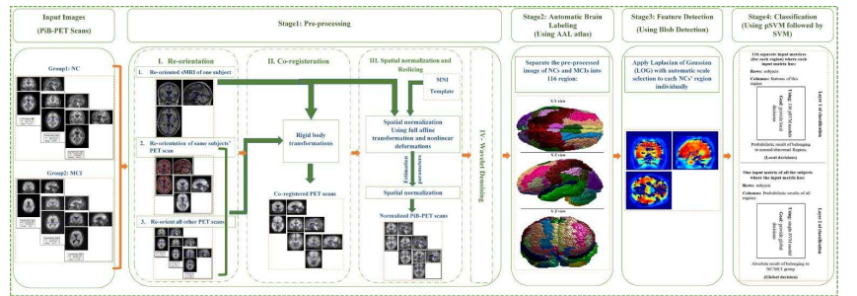

**Figure 5:** CAD System for AD Diagnosis

Two step strategy anticipated for a future CAD System. Hybrid fuzzy-genetic-possibilistic model is used in the technique where the volume estimations of the WM, GM, and CSF are computed. Moreover, it involves an SVDD discriminative classifier on the extracted tissue maps. The SVDD model helps distinguishes between normal old age versus AD and the identification of outliers reinforces the confidence of the CAD system (Lazli et al., 2019). It’s a strong CAD system that affords good quantitation of the tissues with variable imaging conditions like noise, partial volume effect, and heterogeneous spatial intensities. The SVDD classification has been shown to be more effective, with high prediction accuracy, sensitivity, specificity and area under ROC curve.

**9. Limitations of the Study**

* This paper mainly looks at studies on Alzheimers or other neuro degenerative diseases. This, however, may limit the wider applicability of the findings to other diseases.
* Published studies have a chance of bias publication, which is one possibility. The inclusion of unpublished grey literatures may present some additional relevant information which was not taken into consideration in this review, thus affecting the completeness of the study.
* In this case, only literature that was published between 2010 and 2023 has been considered in this study. The time constraint could exclude previous studies done before 2010 or even subsequent publications carried out after the studies’ cutoff point would be detrimental towards the study’s timeliness and comprehensiveness.

**10. Conclusion**

A comprehensive systematic review on multimodal fusion imaging techniques in disease diagnosis shed light into the evolving landscape of neurodegenerative disease’s diagnosis, especially for AD.L Neurodegenerative diseases can be diagnosed using a combination of multiple imaging approaches such as magnetic resonance imaging (MRI), positron emission tomography (PET), and convolutional neural networks(CNNs). Therefore, this review supports a strategy of using multi-model fusion model approaches for coping with neuropathology-diagnostic obstacles. A greater understanding and perception of various diseases occur by joining several pictures from numerous sources, which help health practitioners to select the most appropriate approach for their patients. These techniques were used in different types of studies that involved both the cognitively normal to MCI and AD patients. One of the important highlight in this initiative by Kang et al. (2021) is the use of ensemble learning architectures in disease diagnosis. The presented ensemble model, using 2D CNNs with a multi-slice approach, demonstrates the power of integrating multiple models and spatial features to provide superior accuracy distinguishing AD from NC subjects. Therefore, this methodology supports the actuating diagnosis of AD and provides an adaptable blueprint for others serving broader utilization and interchangeability of multi-modal fusion techniques.

Additionally, the review delves into the utility of MR/PET imaging fusion in diagnosing AD as demonstrated by Song et al. (2021). A new modality developed, GM-PET, by fusing gray matter tissue areas from both imaging techniques and highlighting major regions in AD diagnosis, but maintaining structural and metabolic components. The suggested fusion strategy beats both single modality and feature fusion strategies demonstrating the promising future for the presented approach for enhancing combined diagnostic performance. Despite these showing positive signs, it is important to acknowledge the limiting factors.

The wide use of multi-modalities is impeded by data source heterogeneity, varied imaging protocols, as well as standardized means for fusing multimodality techniques. Also, understanding the fused images and extrapolation of findings to different population groups has not been adequately explored. Additionally, the systematic review emphasizes on transformation of neurodegenerative diseases diagnosis through multi-model fusion image. The use of various imaging methods alongside novel approaches boosts diagnostic precision thus improving patient care. As technology continues its development, it can give rise to more studies that may eventually develop unique methods of testing diseases as well as treating patients.

**References**

1. Deng, Z., Zhu, L., Hu, X., Fu, C., … X. X.-P. of the, & 2019, undefined. (n.d.). Deep multi-model fusion for single-image dehazing. *Openaccess.Thecvf.ComZ Deng, L Zhu, X Hu, CW Fu, X Xu, Q Zhang, J Qin, PA HengProceedings of the IEEE/CVF International Conference on, 2019•openaccess.Thecvf.Com*. Retrieved December 14, 2023, from http://openaccess.thecvf.com/content_ICCV_2019/html/Deng_Deep_Multi-Model_Fusion_for_Single-Image_Dehazing_ICCV_2019_paper.html
2. Du, J., Li, W., Lu, K., Neurocomputing, B. X.-, & 2016, undefined. (n.d.). An overview of multi-modal medical image fusion. *Elsevier*. Retrieved December 14, 2023, from https://www.sciencedirect.com/science/article/pii/S092523121630649X
3. Kang, W., Lin, L., Zhang, B., Shen, X., … S. W.-C. in B., & 2021, undefined. (n.d.). Multi-model and multi-slice ensemble learning architecture based on 2D convolutional neural networks for Alzheimer’s disease diagnosis. *Elsevier*. Retrieved December 14, 2023, from https://www.sciencedirect.com/science/article/pii/S0010482521004728
4. Lazli, L., Boukadoum, M., Sciences, O. A. M.-B., & 2019, undefined. (n.d.). Computer-aided diagnosis system of Alzheimer’s disease based on multimodal fusion: tissue quantification based on the hybrid fuzzy-genetic-possibilistic model and. *Mdpi.ComL Lazli, M Boukadoum, O Ait MohamedBrain Sciences, 2019•mdpi.Com*. Retrieved December 14, 2023, from https://www.mdpi.com/2076-3425/9/10/289
5. Maqsood, S., Control, U. J.-B. S. P. and, & 2020, undefined. (n.d.). Multi-modal medical image fusion based on two-scale image decomposition and sparse representation. *Elsevier*. Retrieved December 14, 2023, from https://www.sciencedirect.com/science/article/pii/S174680941930391X
6. Ortega, S., Halicek, M., Fabelo, H., … G. C.-B. O., & 2020, undefined. (n.d.). Hyperspectral and multispectral imaging in digital and computational pathology: a systematic review. *Opg.Optica.Org*. Retrieved December 14, 2023, from https://opg.optica.org/abstract.cfm?uri=boe-11-6-3195
7. Song, J., Zheng, J., Li, P., Lu, X., Zhu, G., & Shen, P. (2021). An Effective Multimodal Image Fusion Method Using MRI and PET for Alzheimer’s Disease Diagnosis. *Frontiers in Digital Health*, *3*. https://doi.org/10.3389/FDGTH.2021.637386/FULL
8. Tan, W., Tiwari, P., Pandey, H. M., Moreira, C., & Jaiswal, A. K. (2020). Multimodal medical image fusion algorithm in the era of big data. *Neural Computing and Applications*. https://doi.org/10.1007/S00521-020-05173-2
9. Tong, T., Gray, K., Gao, Q., Chen, L., recognition, D. R.-P., & 2017, undefined. (n.d.). Multi-modal classification of Alzheimer’s disease using nonlinear graph fusion. *Elsevier*. Retrieved December 14, 2023, from https://www.sciencedirect.com/science/article/pii/S0031320316303247
10. Wang, H., Computer, H. X.-2009 I. S. on, & 2009, undefined. (n.d.). Multi-mode medical image fusion algorithm based on principal component analysis. *Ieeexplore.Ieee.OrgH Wang, H Xing2009 International Symposium on Computer Network and Multimedia, 2009•ieeexplore.Ieee.Org*. Retrieved December 14, 2023, from https://ieeexplore.ieee.org/abstract/document/5374652/
11. Wang, S., Chen, X., Li, Y., Journal, Y. Z.-C. M., & 2016, undefined. (2016). Application of multimodality imaging fusion technology in diagnosis and treatment of malignant tumors under the precision medicine plan. *Mednexus.OrgSY Wang, XX Chen, Y Li, YY ZhangChinese Medical Journal, 2016•mednexus.Org*, *129*(24), 2991–2997. https://doi.org/10.4103/0366-6999.195467
12. Zhang, C., Yi, L., Feng, Z., Gao, Z., … X. J.-J. of E., & 2019, undefined. (2019). Multimodal image fusion with adaptive joint sparsity model. *Spiedigitallibrary.OrgC Zhang, L Yi, Z Feng, Z Gao, X Jin, D YanJournal of Electronic Imaging, 2019•spiedigitallibrary.Org*, *28*(1), 13043. https://doi.org/10.1117/1.JEI.28.1.013043
13. Zhang, T., Methods, M. S.-J. of N., & 2020, undefined. (n.d.). Multi-modal neuroimaging feature fusion for diagnosis of Alzheimer’s disease. *Elsevier*. Retrieved December 14, 2023, from https://www.sciencedirect.com/science/article/pii/S0165027020302181